**Product Summary**

* LogRocket is a logging and session replay software that works with Javascript apps and websites
* It’s a SaaS business model, with Good/Better/Best packaging that starts with a free tier, and graduates to custom pricing as more features and data needed
* Fast to get set up for technically proficient users

**Homepage**

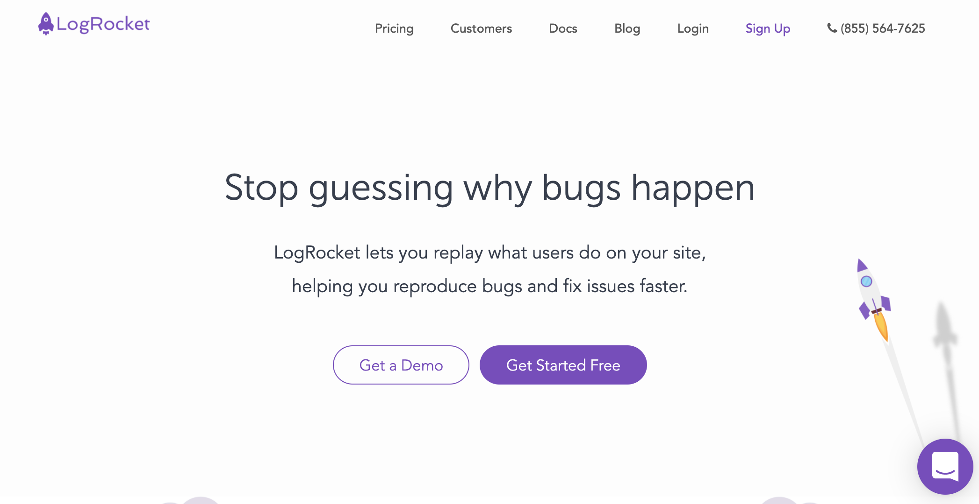

* Clean minimalistic homepage design with obvious calls to action
* Clear description of what the software does that can be understood by technical and non technical users
* User friendly sign up form only asking for email and password, or signing up via google/github

**Welcome Screens**

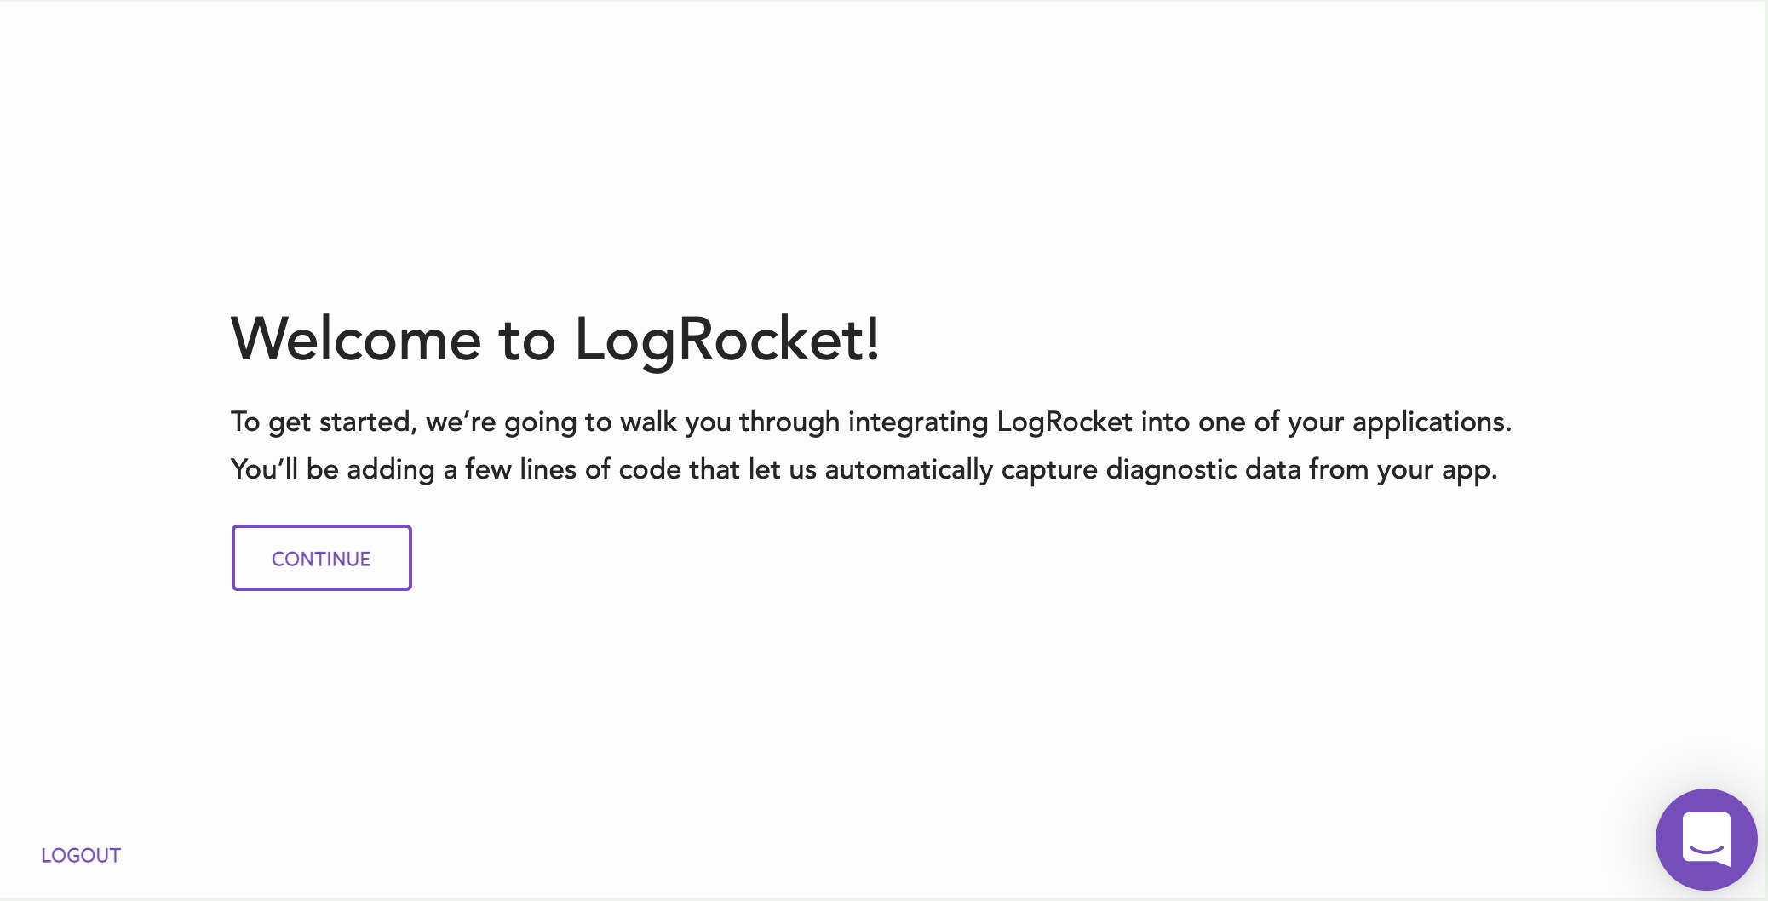

* Great first screen with a welcome message explaining that you’ll be walked through product setup
* Welcome message is only thing on page that can grab users’ attention

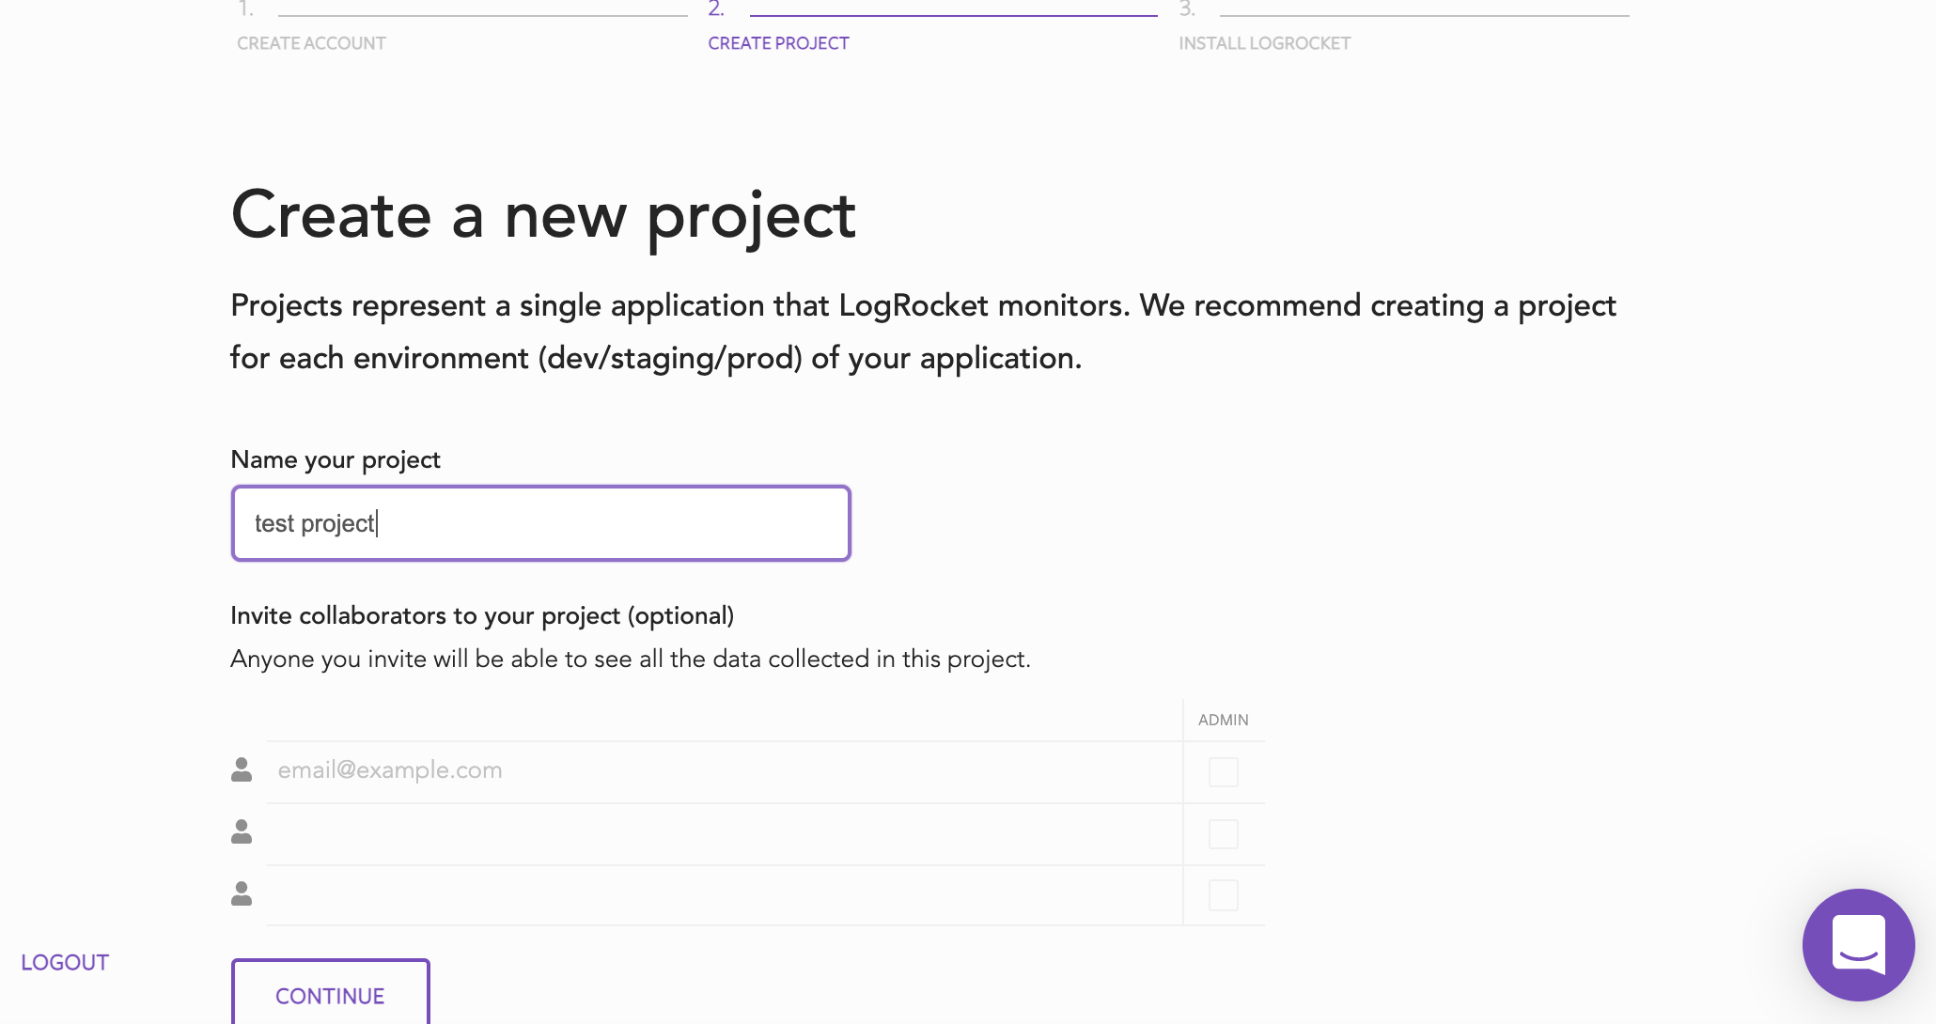

* Create project screen also minimal, with a clear call to action for user

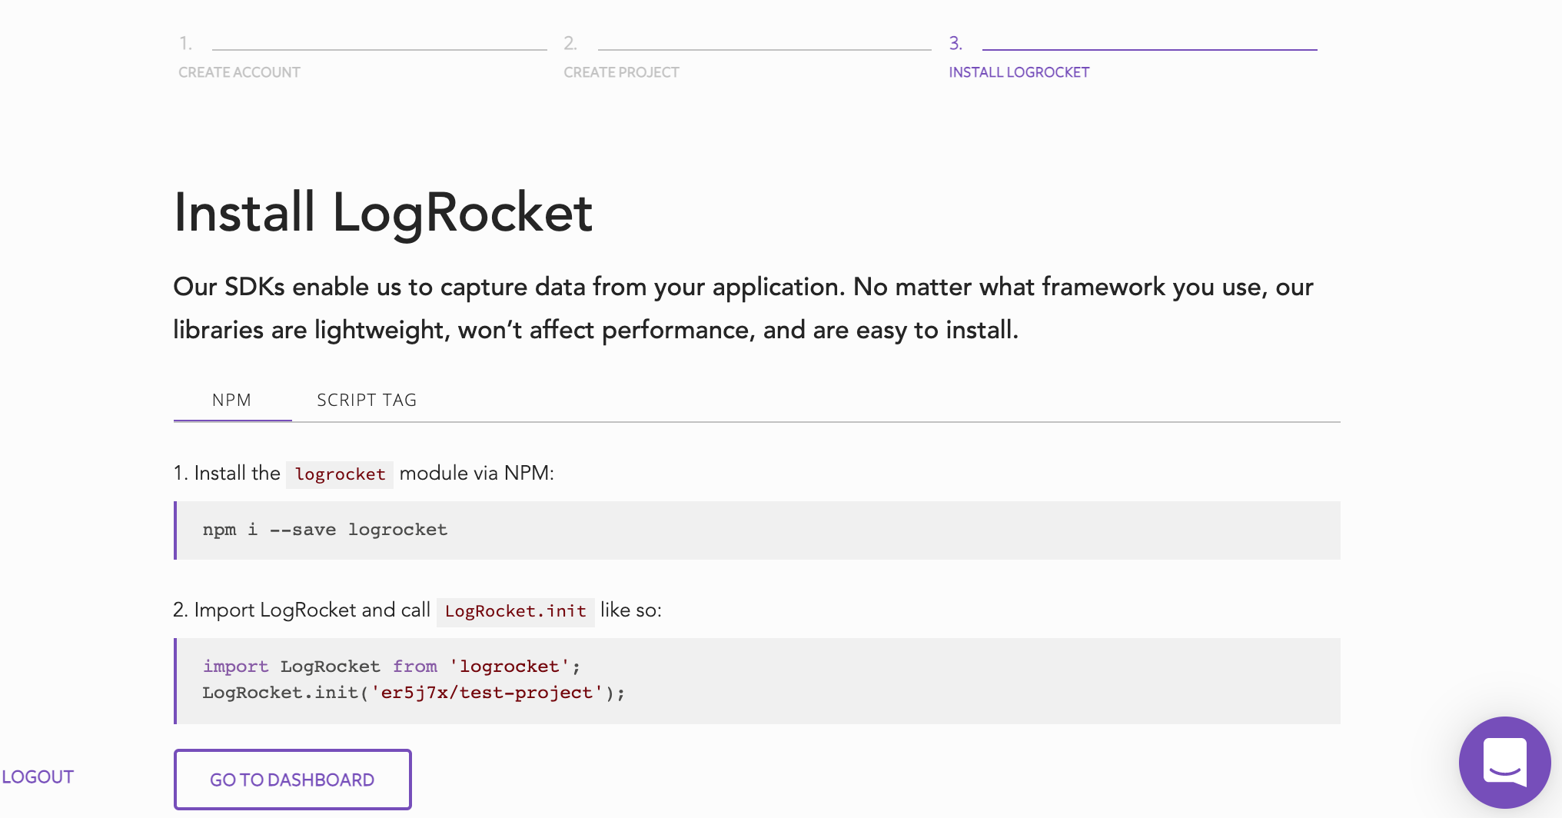

* There's an opportunity to AB test for more clarity on this page. The product so far is so clear that it can be easily understood by technical and non technical users. This page assumes technical knowledge. There’s no explanation of SDKs, NPM, or where this code should be installed. Could those elements be added in an AB test?

**Dashboard Screens**

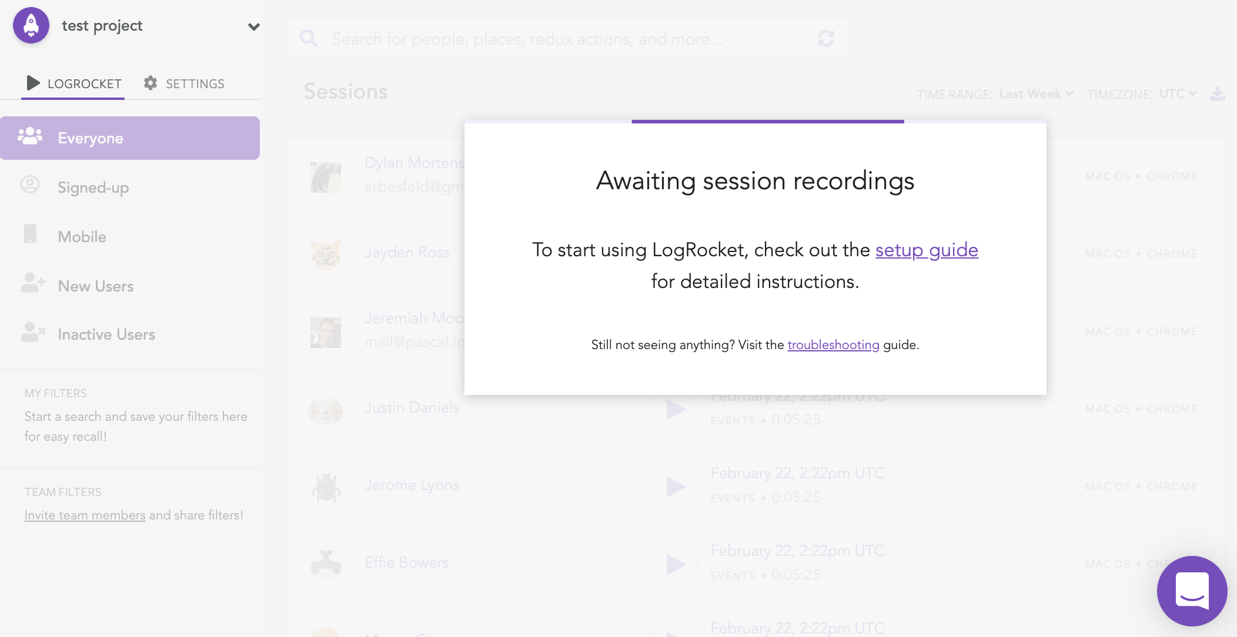

* There’s an opportunity here as well. Purple line on top of ‘Awaiting session recordings’ pop-up keeps buffering. Since people are so behaviorally trained to wait for a buffering screen to eventually finish loading, having this type of pop-up is an interesting choice. Could an AB test remove that buffering line and say ‘Please go to setup guide to finish project setup’?

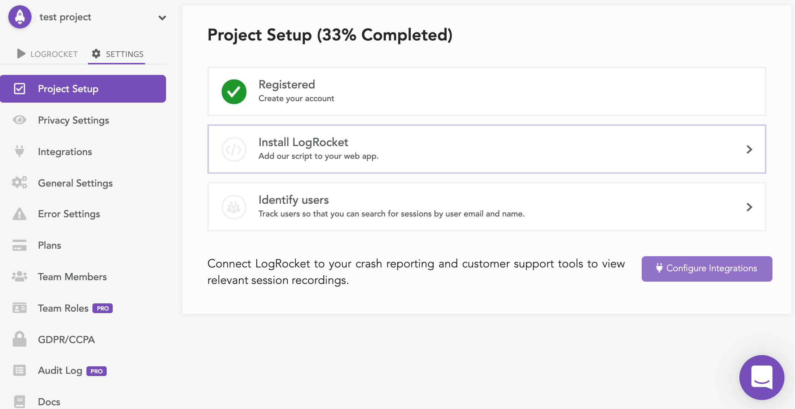

* Very clean UI with a clear to-do list for finishing project setup
* Opportunity to AB test left side navigation. Does showing that many options distract users from finishing project setup? What if only a few options were showing until the project was 100% complete?

**Left Navigation Screens**

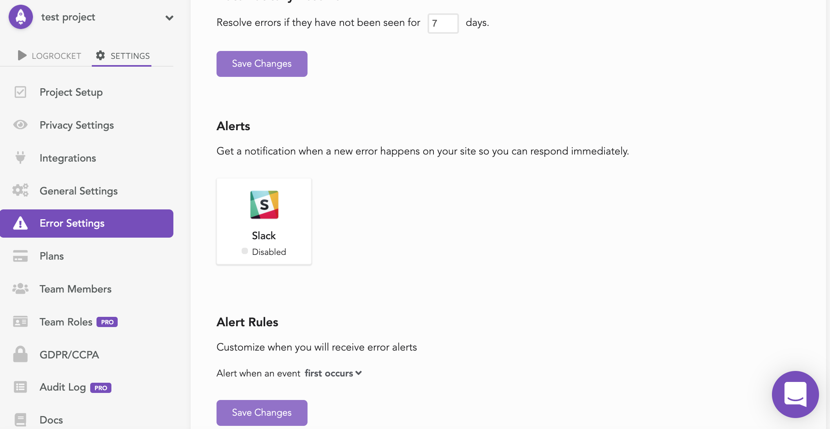

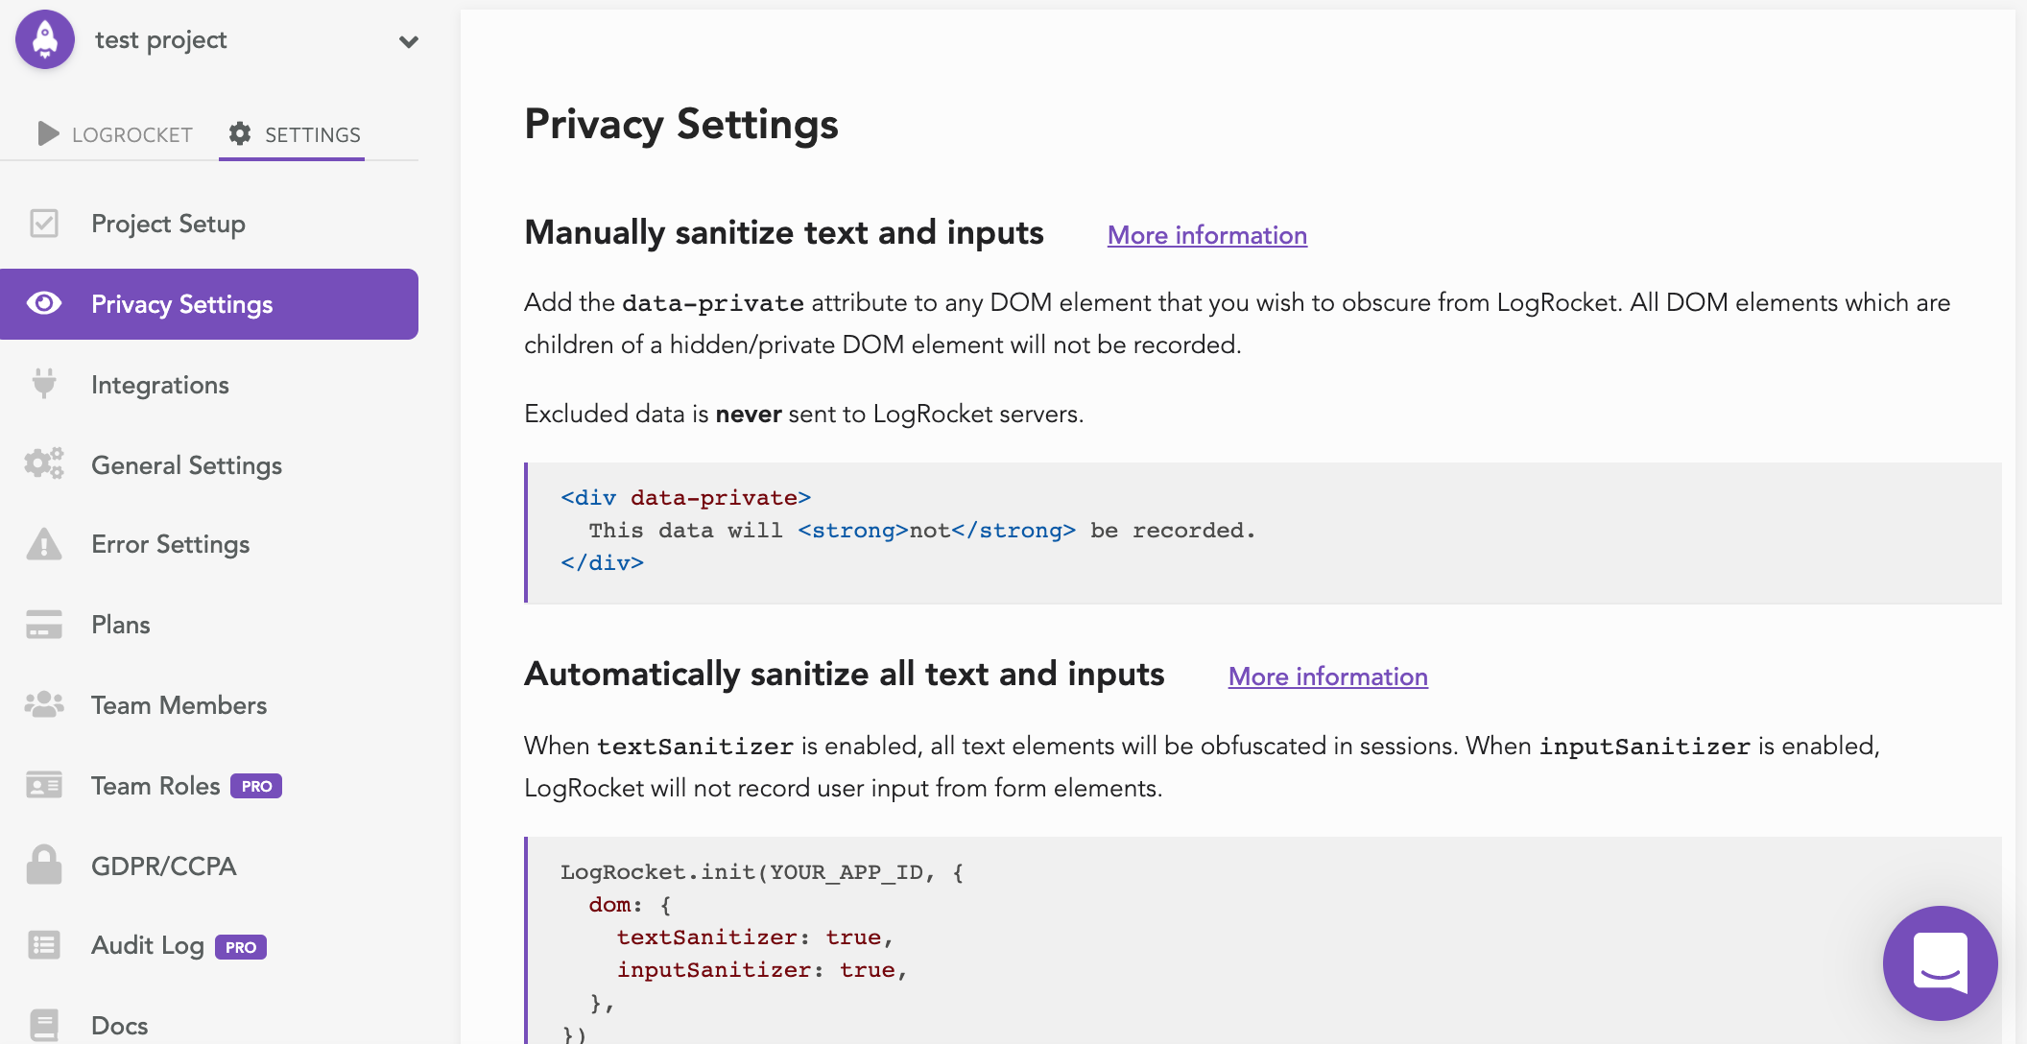

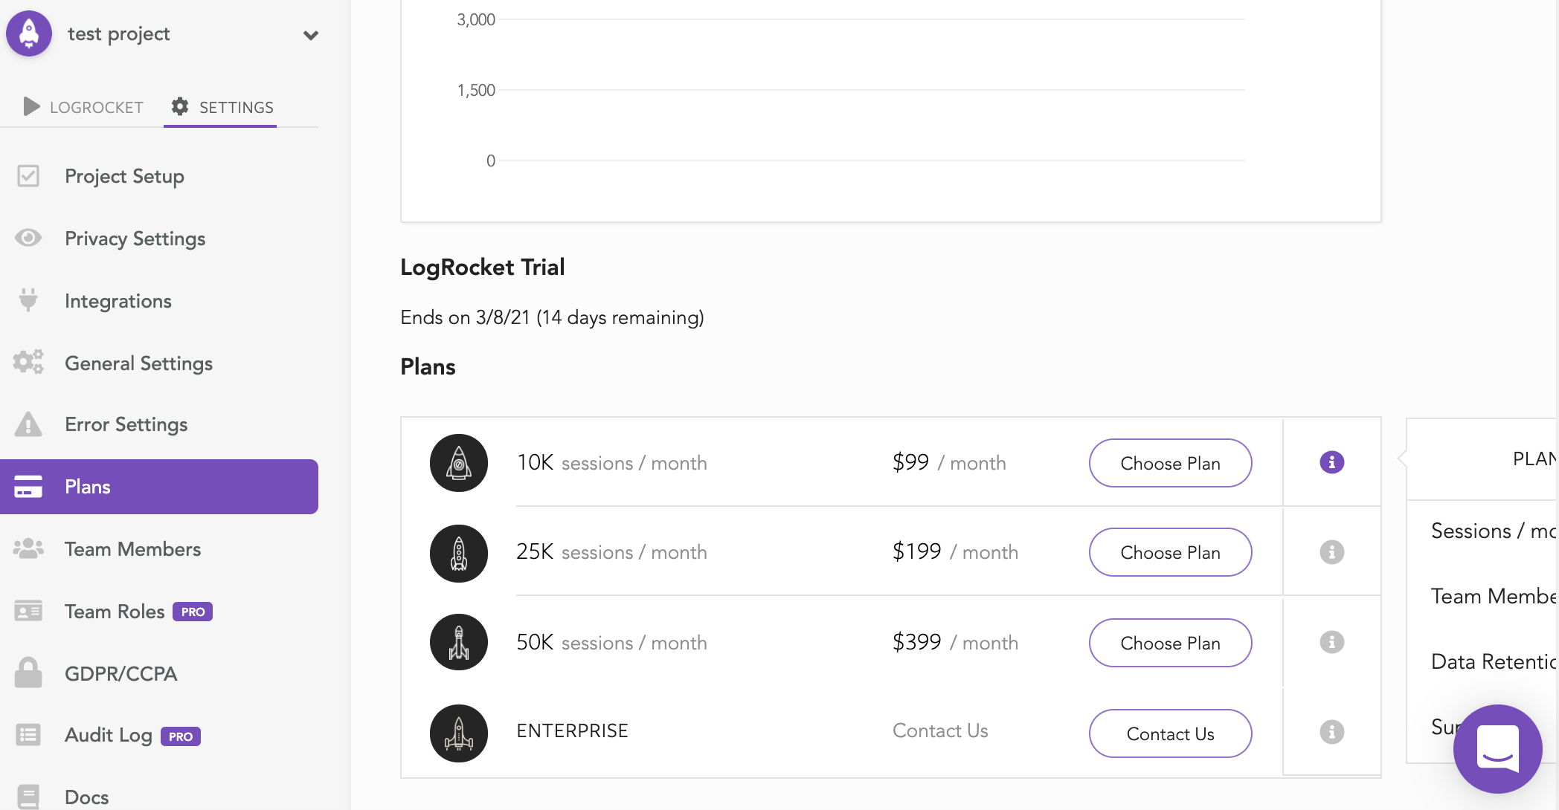

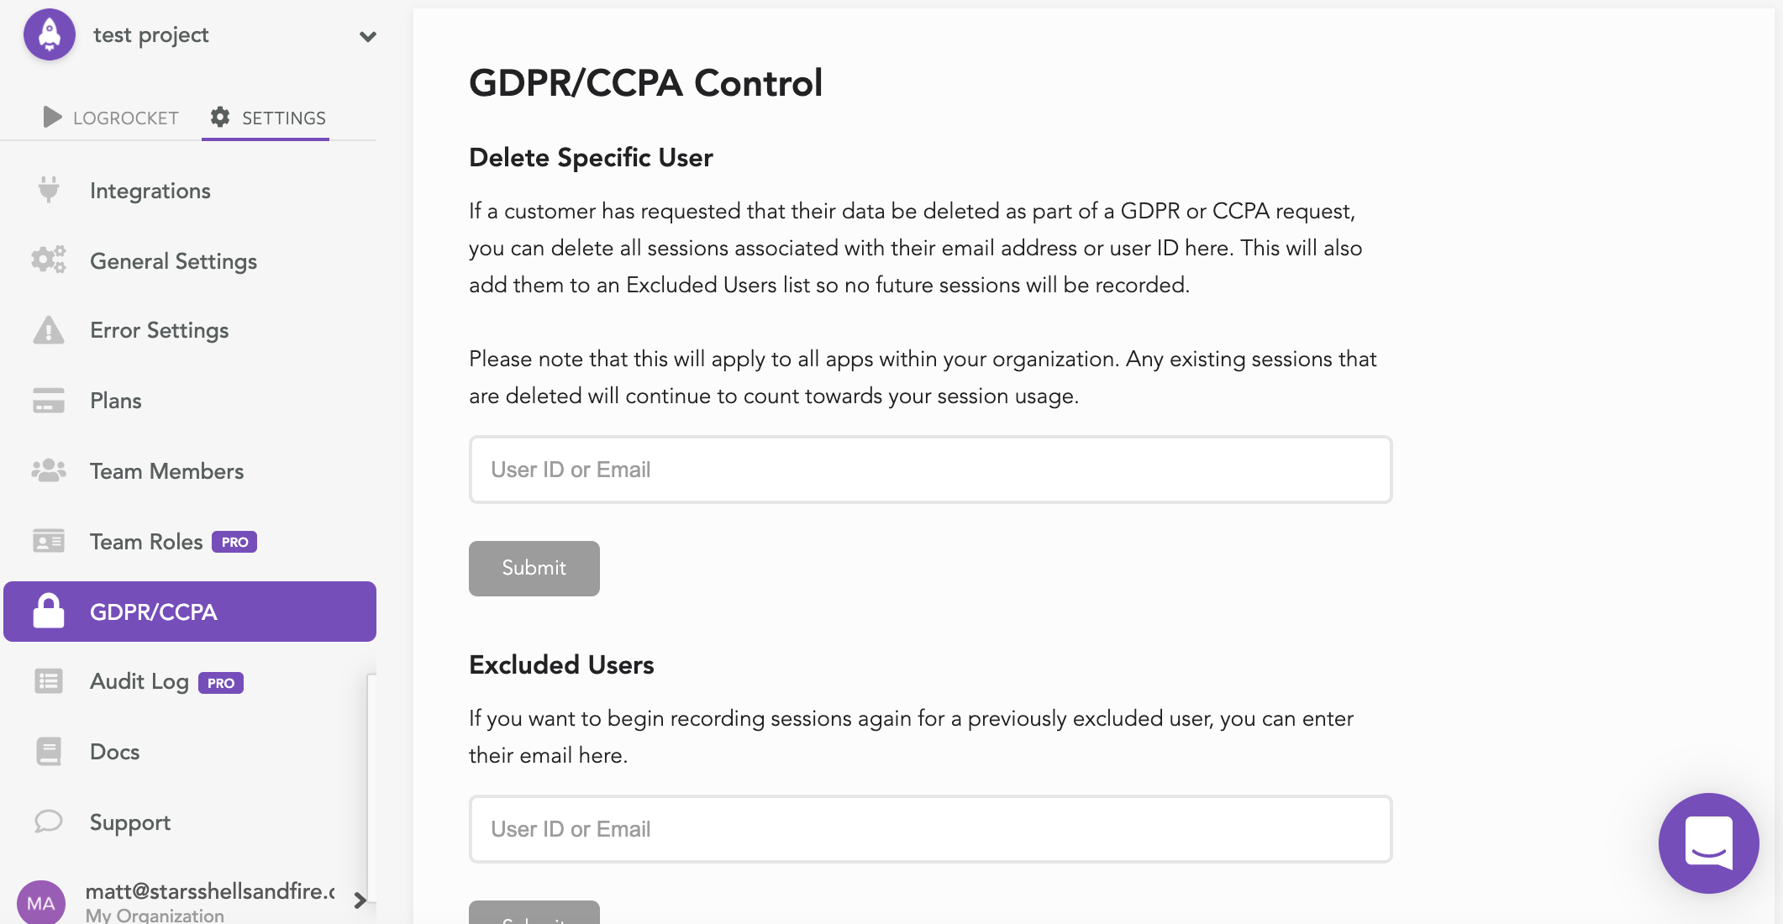

* Good flexibility in terms of handling errors and getting notifications
* Privacy settings could use DOM explanation for non technical users
* Easy to understand pricing grid with benchmarks for higher tiers, although the plan details get cut off on right side of browser if the user doesn’t have their browser in full screen mode
* Very easy to delete user data that has requested it